**Firas El Naboulsi**

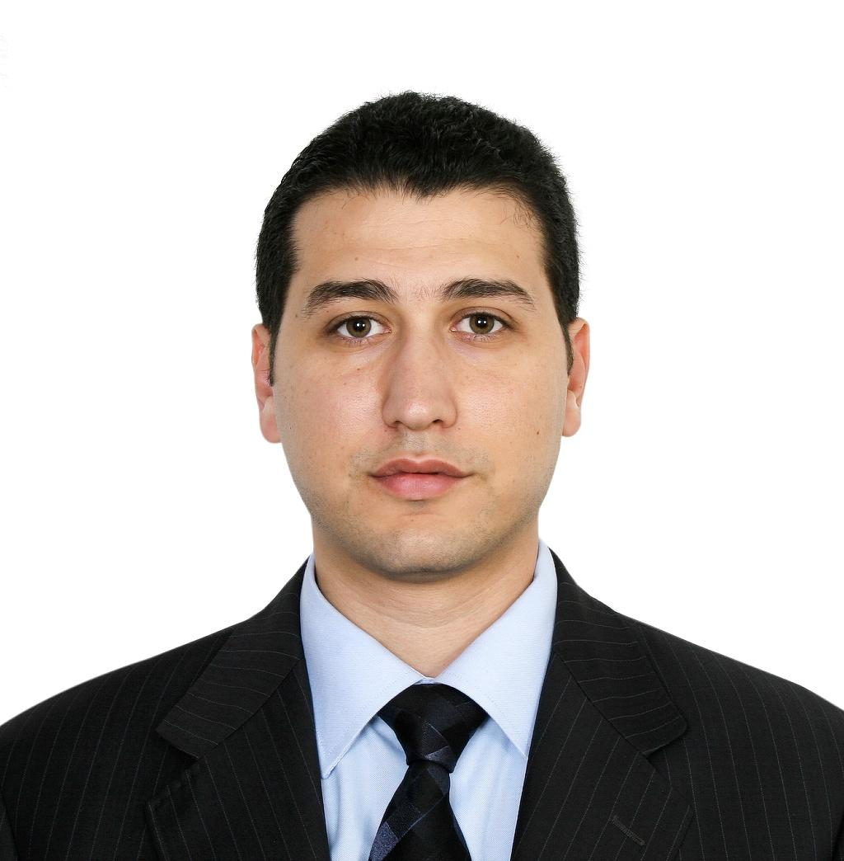

Dubai, United Arab Emirates  
E-mail : [f.naboulsi@engineer.com](mailto:f.naboulsi@engineer.com)

Mobile: +971 50 854 1790 | +961 71 767630

* + **Personal information**
* Birth date: 25 March 1979
* Gender: Male
* Marital status: Married
* Nationality: Lebanese
  + **Career objective**
* Seeking a challenging position in Construction Industry, where about **Twenty years** of experience will add value.
  + **Summary of Qualification and professional skills**

**Education details:**

1996-2002: **Diploma in Civil Engineering** option **Structure**. (Lebanese University - Tripoli)

May 2008: Training Course **“Improving Sales Skills”** (Dubai-UAE)

**Activities:**

Affiliated Member of the **“Order of Engineers and Architects of Tripoli – Lebanon”** Since 2002

**Computer Skills:**

* MS Office Expert
* AutoCAD 2012 Good
* Primavera 3.1 Good
* ROBOT 15 Good

**Language:**

Fluent in Arabic, English and French

* + **Professional Experience**

**Bond Interiors L.L.C.**

*Provide: Turnkey Interior Fit-out • Sustainable Products for Interior Fit-out*

( [www.bondinteriors.com](http://www.bondinteriors.com) )

**April 2022 – Present**

*Position:*  Sales Manager

*Responsibilities:*

* Design and implement a strategic business plan that expands company’s customer base and ensure its strong presence
* Own recruiting, objectives setting, coaching and performance monitoring of sales representatives
* Build and promote strong, long-lasting customer relationships by partnering with them and understanding their needs
* Present sales, revenue and expenses reports and realistic forecasts to the management team
* Identify emerging markets and market shifts while being fully aware of new products and competition status

**MHE Group**

*Provide: Turnkey Construction Service • Project Management Service • Consulting*

( [www.mhe-international.com](http://www.mhe-international.com) )

**Nov 2020 – Mar 2022**

*Position:*  Projects Manager

*Responsibilities:*

* Managing a team of Architectural and Structural civil engineers
* Defining clients' needs and translating them into designs for new facilities, equipment, or systems.
* Conducting initial fact-finding surveys, project inception, formulation, and concept planning.
* Managing and supervising engineering projects for clients, sometimes internationally.
* Supervising subcontractors who provide specialist assistance for parts of the project.
* Organizing the project logistics, including purchasing and supply chain management.
* Liaising with others involved, including architects, local authorities, and manufacturers.

**Tajj Est. - Beirut, Lebanon**

*General Contracting Company*

**July 2014 till Nov 2020**

*Position:*  Projects Manager

**Project Name**: El Minieh Region Potable Water Supply Project – North Lebanon

**Owner**: Council for Development and reconstruction - **CDR**

**Consultant**: Dar Al Handasah Nazih Taleb & Partners

**Duration**: 60 Month

**Project Description**: The Project consist of Catching Structures of Oyoun Assamak springs, Two Wells, Ductile Iron Transmission Line, nine water tanks, Polypropylene Distribution Lines, House Connections and other Works

**Project Name**: Water Supply System at El Fouar Municipality – Zgharta District – North Lebanon

**Funded by:** European Union

# Client: Comitato Internazionale Per Lo Sviluppo Dei Popoli- CISP

**Consultant** : Bureau Technique Pour Le Developpement (BTD) – Beirut ­- Lebanon

**Duration**: 12 Month

**Project Description**: The Project consist of Well Preparation, 1500 m3 Water Tank, Ductile Iron Pumping Line, Polypropylene Distribution Line with House Connections, and other Works

*Responsibilities:*

* Provide leadership, direction, and motivation to the project team.
* Liaise with suppliers, consultants and sub-contractors as required.
* Prepare, manage, review, and update the project plan
* Prepare and manage key project plans including risk management plan, communication plan, completion, and handover plan so on, in conjunction with other project roles.
* Manage project variations and changes and maintain the change control process.
* Manage project costs through cost estimating, budgeting, and monitoring.
* Ensure appropriate quality standards and quality assurance requirements are met.
* Ensure the project schedule is maintained and regularly report progress.
* Manage the risks management process, including the development of contingency plans.
* Monitor overall progress, use of resources, and initiate corrective action where necessary.
* Establish the project administration systems, documents control and management of all records.
* Coordinate and prepare regular progress reports and communication with key stakeholders.
* Coordinate handover and completion activities.

**Iimar General Contracting- Tripoli, Lebanon**

*General Contracting Company*

**July 2011 till July 2014**

*Position:*  Projects Manager

**Project Name**: Preparation and Cold Rooms for Agriculture Products in Akkar – North Lebanon

**Owner**: Kuwait Fund for Arab Economic Development

**Consultant**: Spectrum Engineering Consultant

**Duration**: 19 Month

**Project Description**: The Project consist of Nine different buildings: Preparation and Packing area (post tension beams with prestressed roof panels), Cold rooms, Administration block, Exhibition Hall with attached offices, School and laboratory building, Guard house, Garbage room, 20m high rise water tank and Service block with external works such as Asphalt Roads, Sewage Network, Retaining Walls, Pavers, Pole lights, Soft and Hard Landscaping and others

**Project Name**: Reconstruction of Al Muhajareen Area in Nahr El Bared Refugee Camp – North Lebanon

**Funded by:** European Union

**Client**: Norwegian Refugee Council - **NRC**

**Consultant**: Archideco / B.E.C.A. – Tripoli - Lebanon

**Duration**: 12 Month

**Project Description**: The Project consist of Sixteen Buildings, each building contains between Three to Seven blocks, which count in total 110 residential units including external works such as Asphalt Roads, Sewage Network, Pavers, Soft and Hard Landscaping and others

*Responsibilities:*

* Oversee and direct construction projects from conception to completion
* Review the project in-depth to schedule deliverables and estimate costs
* Oversee all onsite and offsite constructions to monitor compliance with building and safety regulations
* Meet contractual conditions of performance
* Review the work progress on daily basis
* Prepare internal and external reports pertaining to job status
* Plan to prevent problems and resolve any emerging ones
* Negotiate terms of agreements, draft contracts and obtain permits and licenses
* Analyze, manage and mitigate risks
* Ensure quality construction standards and the use of proper construction techniques

**German Emarati Company - BENA (Abu Dhabi-UAE)**

*UAE’s leading manufacturer of high quality precast aerated concrete PAC in a state of the art facility in Musaffah, Abu Dhabi*

(www.bena.ae)

**Jun 2008 – Jun 2011**

*Position:*  Projects Manager

*Responsibilities:*

* Perform preliminary structural layout and comments to be submitted and approved by consultant/client
* Perform preliminary cost estimate of the super structure
* Check for the availability of site utilities such as transportation, accommodation, site offices and storage facilities
* Execute contract with Client/Consultant
* Prepare final permit structural calculations, drawings, and specifications
* Provide copy of the approved structural plans to Construction
* Prepare: Construction schedule, Equipment list, Material list, Personnel list, Organizational chart with CV’s, Shop drawings, PAC Material order, Production schedule with Production Manager, Testing and reporting requirements, Job cost spreadsheet
* Following up and communicating between the Factory and the Construction department on site to ensure that the job is on track

**System Construct L.L.C. (Dubai-UAE)**

*UAE’s leading industrial Contractor in turnkey construction of Pre-engineered steel buildings, RCC and Precast Buildings* ([www.systemconstruct.com](http://www.systemconstruct.com))

**Feb 2005 – May 2008**

*Position:* Business Development Manager

*Responsibilities:*

* Searching for new clients that could benefit from company services.
* Establishing new and maintaining existing long-term rapports with customers.
* Managing and controlling pre-qualification process with allocated government and private Developers.
* Securing the flow of leads and converting leads to projects.
* Preparing full scope of work for the projects based on the client requirements.
* Estimating and bidding for projects, negotiating & signing contracts.
* Follow up with all related departments such as Architectural and Structural Design, MEP, Fire Fighting, Drainage and Water Treatment Systems, for Turnkey Design and Build Projects.
* Follow up preparation of Construction Program, Method Statements and Site Organization Charts…etc.

**Unitech CO-Middle East (Dubai-UAE)**

*A Leader in manufacturing and supplying architectural and steel materials and AEG power tool supplier – Part of IKK Group of Companies* ([*www.ikk-group.com*](http://www.ikk-group.com))

**2002-2005**

*Position:* Sales consultant

*Responsibilities:*

* Sell our products to clients to fulfill on their business needs.
* Work with clients and prospects to develop project scope and approach, regularly interfacing with the most senior level executives of the client.
* Bring a strategic business planning approach to engagements.
* Communicate effectively at all client levels.
* Quickly grasp client business requirements and fit consulting solutions around those specific needs.
* Manage all phases of the business development cycles to successful close (including proposal development, implementation, estimating, scope, construction, and client presentations).
* Maintain and nurture client relationships to ensure additional business.

**Arabian Construction Company S.A.L (Beirut –Lebanon)**

*Economic housing construction & 3000 m3 Water Tank Construction*

([*www.accsal.com*](http://www.accsal.com))

**Aug 2000 – Dec 2002**

*Position:* Site Engineer

**Project Name**: Low cost housing project – Tripoli

**Owner**: Council for Development & Reconstruction, Lebanon

**Consultant**: Spectrum Engineering Consultant

**Project Description**: The project consisted of 78 residential buildings (980 residential units), a raised water tank and a community center which housed a school and shops with a huge external works such as Asphalt Roads, Sewage Network, Retaining Walls, Pavers, Pole lights, Soft and Hard Landscaping and others

*Responsibilities:*

* Setting out and leveling the site
* Surveying the site; checking drawings and quantities and ensuring that the calculations are accurate for the work.
* Overseeing the selection and requisition of materials and plant for use in the construction.
* Planning the work and efficiently organizing the plant and site facilities in order to meet agreed deadlines.
* Liaising with any consultants, sub-contractors, supervisors, planners, quantity surveyors and the general workforce involved in the project.
* Resolving any unexpected technical difficulties, and other problems that may arise.
* Writing detailed reports.
  + **References**
* Available upon request.